[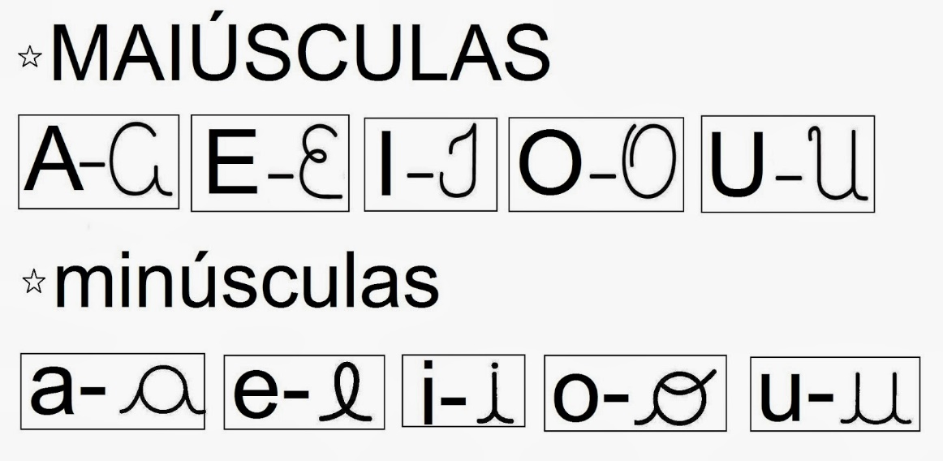](https://www.google.com.br/url?sa=i&rct=j&q=&esrc=s&source=images&cd=&ved=0ahUKEwiw25vx48HMAhULGR4KHQaEAdkQjRwIBw&url=http%3A%2F%2Fblogsambalele.blogspot.com%2F2013%2F11%2Fatividades-com-as-vogais-minusculas.html&bvm=bv.121099550,d.Y2I&psig=AFQjCNEpUKncRhQNFMOOaXDy3VTQEcSZXQ&ust=1462497936752238&cad=rjt)

[](https://www.google.com.br/url?sa=i&rct=j&q=&esrc=s&source=images&cd=&ved=0ahUKEwiw25vx48HMAhULGR4KHQaEAdkQjRwIBw&url=http%3A%2F%2Fblogsambalele.blogspot.com%2F2013%2F11%2Fatividades-com-as-vogais-minusculas.html&bvm=bv.121099550,d.Y2I&psig=AFQjCNEpUKncRhQNFMOOaXDy3VTQEcSZXQ&ust=1462497936752238&cad=rjt)